Starter - What are the accessibility issues?
Look at the starter slide on the board that demonstrates how colour-blind people view different colours. Now identify the issues that could arise from this example web page. In pairs, annotate using lines and text boxes what the issues are and where they occur.

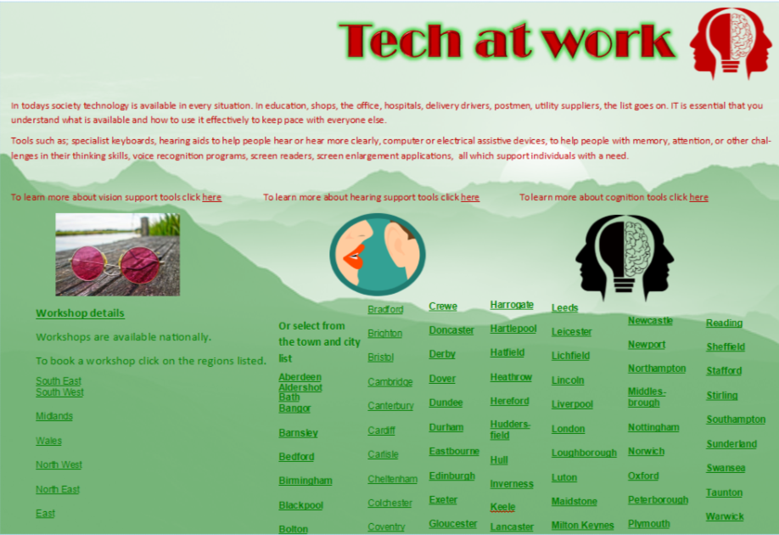

Resources are updated regularly — the latest version is available at: ncce.io/tcc.
This resource is licensed under the Open Government Licence, version 3. For more information on this licence, see ncce.io/ogl.

