Lesson 5 Homework: Selection
Part 1: IF/ELSE
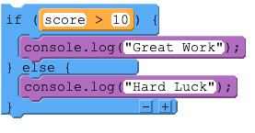
Use the segment of code above to help you answer the questions below.

Q1. What would be displayed in the console if the score variable held the value of 5?

- Great Work would be outputted 🖵
- Hard Luck would be outputted 🖵
- Both Great Work and Hard Luck would be outputted 🖵
- Nothing would happen 🖵

Q2. What would be displayed in the console if the score variable held the value of 10?

- Great Work would be outputted 🖵
- Hard Luck would be outputted 🖵
- Both Great Work and Hard Luck would be outputted 🖵
- Nothing would happen 🖵

Q3. What would be displayed in the console if the score variable held the value of 15?

- Great Work would be outputted 🖵
- Hard Luck would be outputted 🖵
- Both Great Work and Hard Luck would be outputted 🖵
- Nothing would happen 🖵
Part 2: IF/ELSE IF/ELSE
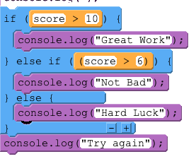
Use the segment of code above to help you answer the questions below.

Q4. What would be displayed in the console if the score variable held the value of 6?

- Great Work would be outputted 🖵
- Not Bad would be outputted 🖵
- Hard Luck would be outputted 🖵
- Both Hard Luck and Try again would be outputted 🖵

Q5. What would be displayed in the console if the score variable held the value of 7?

- Great Work would be outputted 🖵
- Not Bad and Try again would be outputted 🖵
- Hard Luck would be outputted 🖵
- Both Hard Luck and Try again would be outputted 🖵

Q6. What would be displayed in the console if the score variable held the value of 11?

- Great Work would be outputted 🖵
- Both Not Bad and Try again would be outputted 🖵
- Both Great Work and Try again would be outputted 🖵
- Both Hard Luck and Try again would be outputted 🖵
- Both Great Work and Not Bad would be outputted 🖵

