Level 2 – Safe Lock System Code

This task is going to build on the previous lessons by using more variables and comparing them.

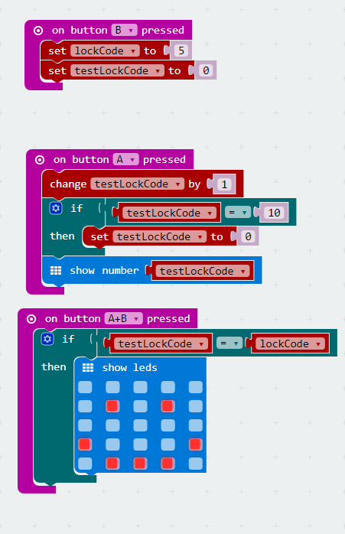

To complete this application you will need to ‘Make Variables’ using the ‘Variable’ function tab. You will also need the ‘Logic’ function tab to create IF statements and compare one variable to another.

Once you have completed the exercise, try out these challenges. Be the geek Ninja!

Challenge 1:


Change the ‘lockCode variable to be a random number between 0 and 9. Use the ‘button A pressed’ and ‘button B pressed’ events to test to see whether the code is actually random.

Challenge 2:
Use a new variable in the A+B button press event to keep score of when the player gets the right code. Each time they do, increase the score by 1 and display it on the screen.

