Level 2/3 – Python on the BBC micro:bit

Follow the instructions on Coding @ Carres to open Makecode in Python mode.

Safe Locker Python Code

Step 1:
When the Python Editor appears on the screen, the first thing you need to do is DELETE ALL of the code which is in there by default.

If you leave any of the default code in, it may make your program not run correctly.

Step 2:
The next step is to type in the code for the Safe Lock program. This can be found on the next page.

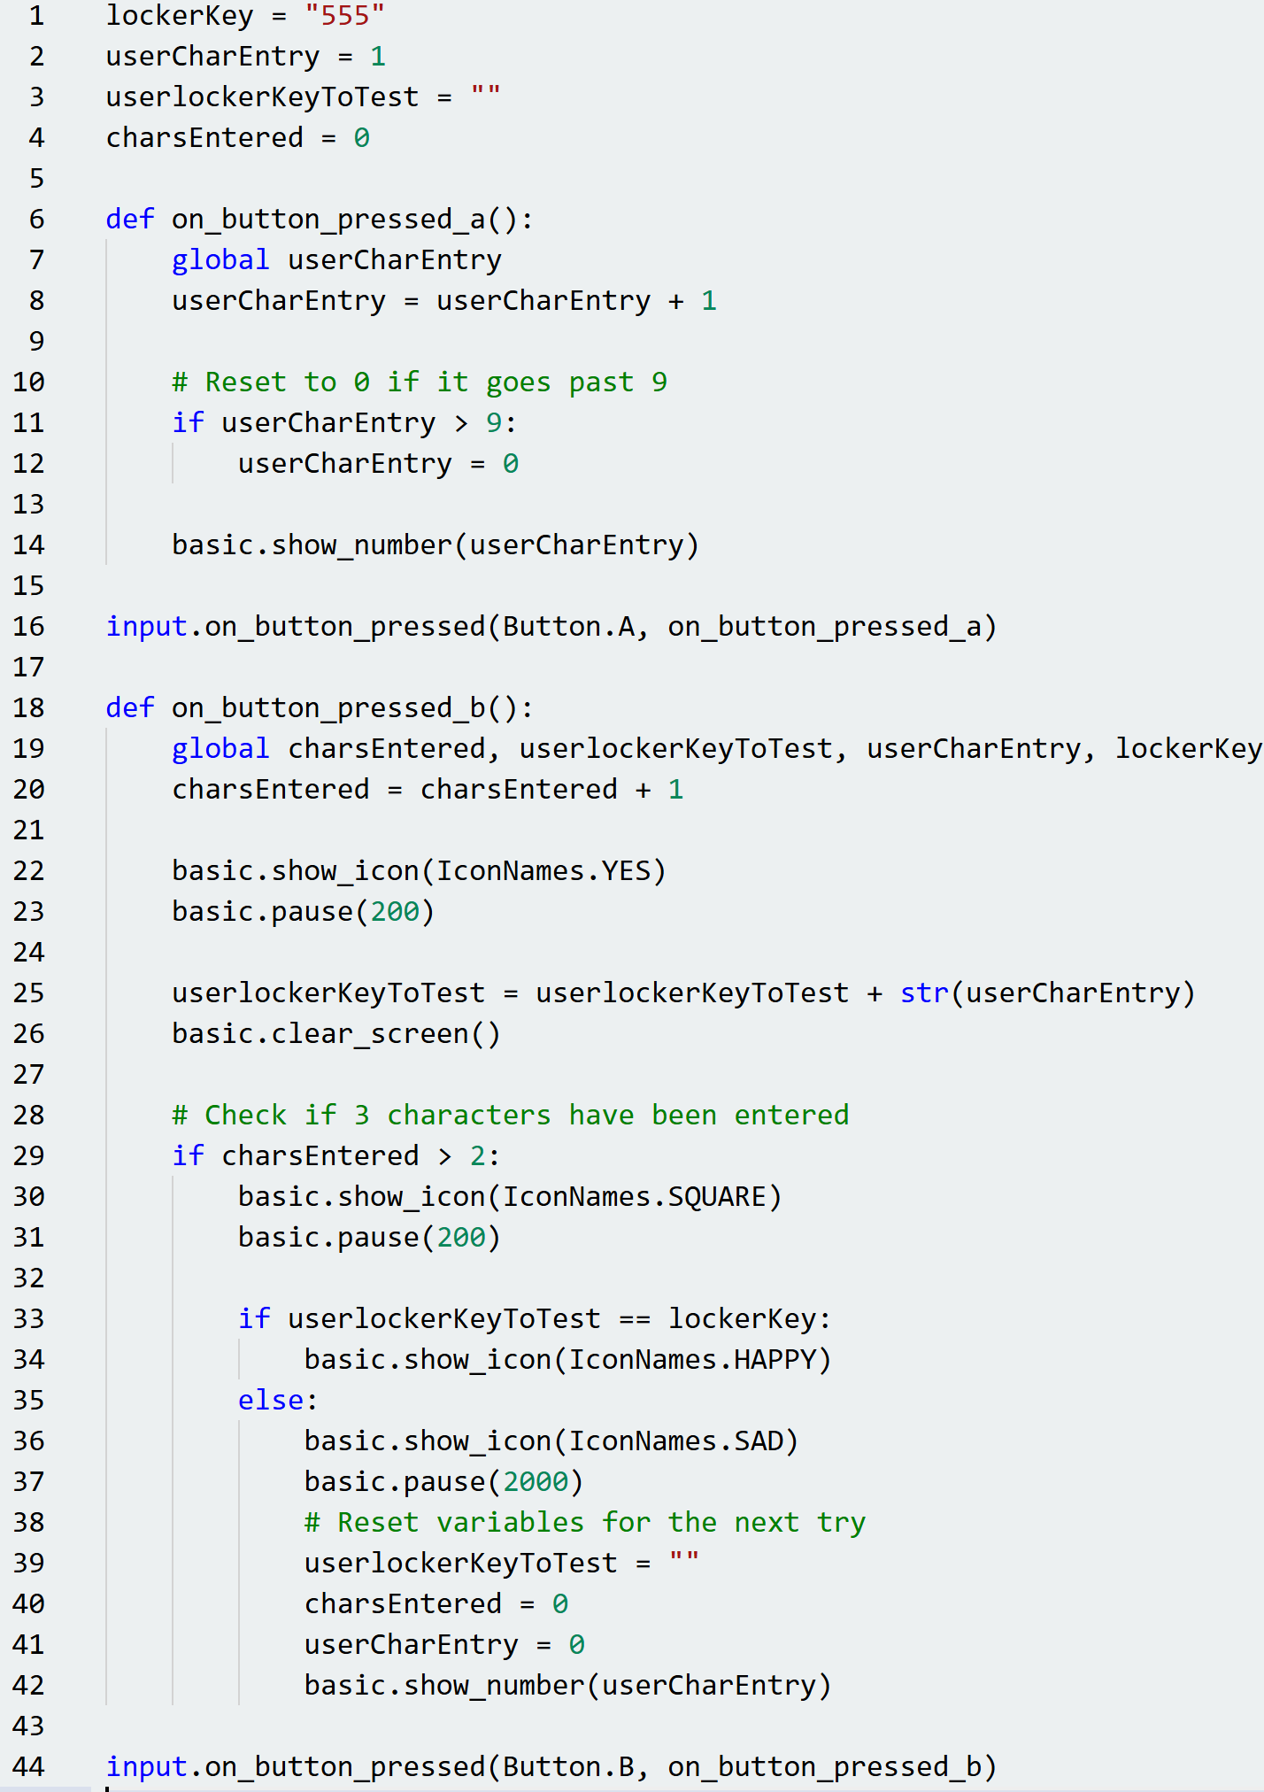

It is REALLY important that this is typed in correctly, including capital letters where they are shown and using TAB on the keyboard to move the cursor across in the IF statements so that the code lines up as shown above.
Step 3:
When you have typed in your code, you will need to run it on the micro:bit. To do this, click the ‘Download’ button like you have done before. Make sure the micro:bit is plugged in.

You do not need batteries to power your micro:bit; it will happily be powered by the USB port it is plugged into. Press button A on the micro:bit to start the program.

Step 5:
This program is more powerful than the JavaScript Blocks Editor because it accepts a three-digit code. Do the following to test it:
- Press the A button repeatedly, until the micro:bit displays the number 5.
- Press the B button. The micro:bit will display a tick and then go blank.
- Repeat the above steps TWO more times.
- The micro:bit should then display a box, then a smiley face to say that the lock is open.
- If you get the combination wrong, it should display a box, then a sad face.


- To restart the micro:bit, press the reset button on the back.

The unlock code for this safe is: 555

Extension
- Try to extend your Python application to use the shake function instead of button B to test the lock.
- Look at the different image options on this website https://microbit-micropython.readthedocs.io/en/latest/tutorials/images.html to change the IMAGE.Sad and IMAGE.Happy to alternatives.

