Level 3 - Plenary Questions
Highlight/bold the correct answers below.

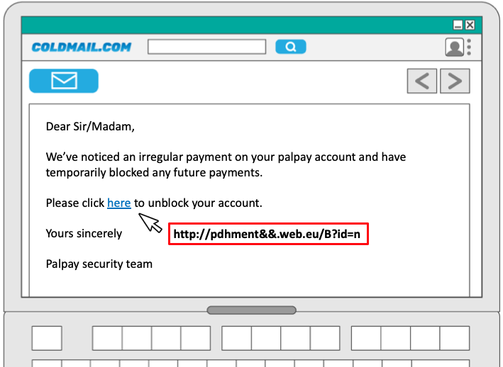

1. The email above may be what type of attack?

A. Shouldering
B. Phishing
C. Blagging
D. Hacking

2. What is the key indication that the email is the type of attack that you gave as your answer in question 1?

3. ‘A set of methods used by cybercriminals to deceive individuals into handing over information that they can use for fraudulent purposes’ is a definition of which of the following key terms?
A. Shouldering
B. Phishing
C. Blagging
D. Social engineering

4. Which of the following is when attackers create short, fun quizzes in an attempt to find out key pieces of information that can help them answer account security questions?

A. Blagging
B. Shouldering
C. Name generator attack
D. Phishing

This resource is licensed under the Open Government Licence, version 3. For more information on this licence, see ncce.io/ogl.

