Level 2 - Number Guessing Game

The number guessing game is a simple program in which the player needs to pick a random number between 0 and 9 and then see whether the micro:bit can guess it.

It works by the player shaking the micro:bit to instruct it to pick a random number and then display it on the screen.

Go to https://makecode.microbit.org/
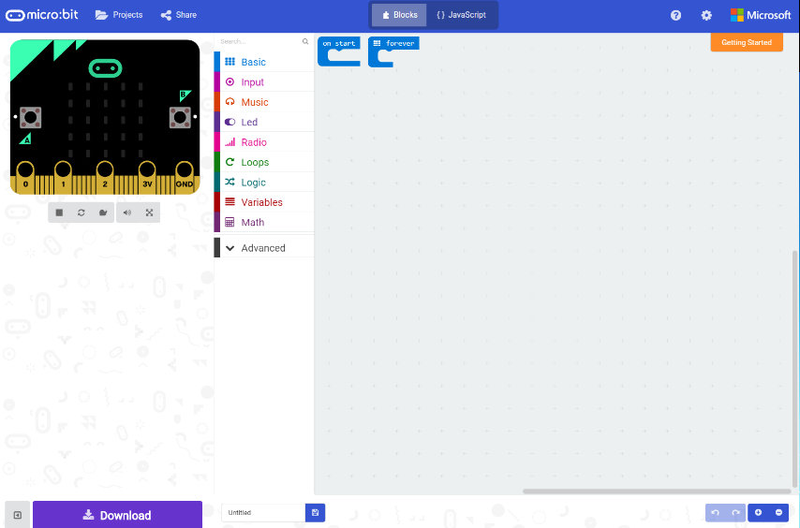
Click on the ‘Let’s Code’ button by the JavaScript Blocks Editor in the top half of the screen.

This will display the Blocks Editor, which you will use for programming. On the left-hand side of the screen is a ‘preview’ micro:bit. As you create your program, you can click on the buttons, etc. in this preview to see your program running and try it. In the middle of the screen are the different code tabs for the main functions of the micro:bit. On the right of the screen is where you will drag code blocks from the function tabs and put them together in order to create your application. This is sort of a programming ‘paste board’.
Step 1:
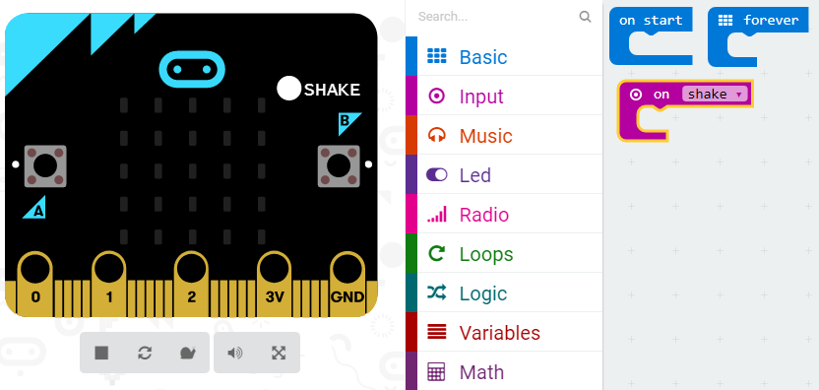
This will add that code block to your paste board. You can also see that it has added a ‘shake’ function to the preview micro:bit on the left-hand side of the screen. When you click on this, the preview will run whatever is in the ‘on shake’ code block.

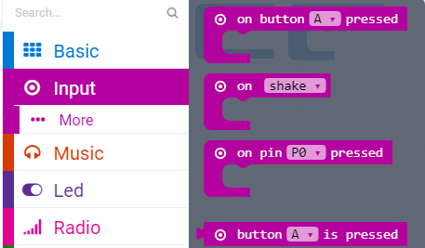
Click on the ‘Input’ function tab in the middle of the screen and double click on the ‘on shake’ block.
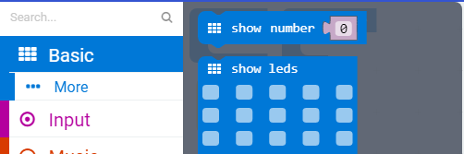
Step 2:
Click on the ‘Basic’ function tab and double click on the ‘show number’ code block. This will add it to your program.

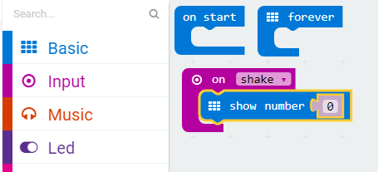
Step 3:
Drag the newly added ‘show number’ code block into the middle of the ‘on shake’ code block. This will attach it.

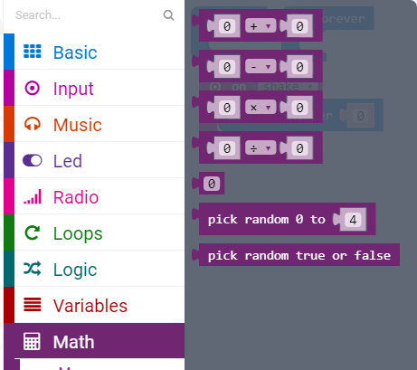
Step 4:
Click on the ‘Math’ function tab and double click on the ‘pick random 0 to 4’ code block. This will add it to your program.

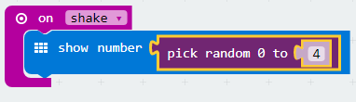
Step 5:
Drag the newly added ‘pick random 0 to 4’ code block into the space on the right-hand side of the ‘show number’ code block. This will attach the two together. The space in the ‘show number’ code block will expand to fit.

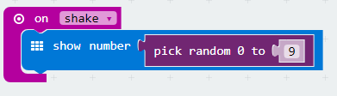
Step 6:
Change the number at the end of the ‘pick random 0 to 4’ code block so that it says ‘pick random 0 to 9’ (shown on the left)

Step 7:
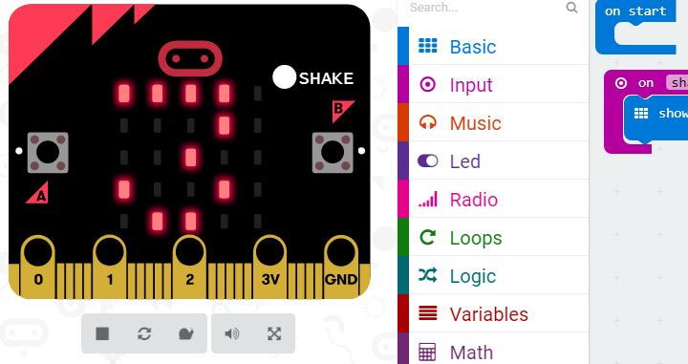
Click the ‘shake’ button on the preview micro:bit on the left-hand side of the screen. This will preview your code. It should display a random number between 0 and 9. Repeatedly clicking on the ‘shake’ button will display random numbers one after another.

Congratulations, you have just written your first micro:bit game. You can now use it to play the ‘Guess the Number’ game. Pick a number in your head and then click the ‘shake’ button. Did the micro:bit guess it correctly? If so, the micro:bit gains a point. If not, you gain a point. The first one to gain 10 points wins.

Too easy? Want to extend your knowledge further? Be the geek Ninja!



Challenge 1:
Creating a scoring system. Add a function to your program to keep the score for you.
Each time you press button A, the micro:bit will increment a score variable by 1 (increment means ‘add to’). The code block below shows you how to do it, but you will need to look at some of the other function tabs to see whether you can work out which blocks you need.

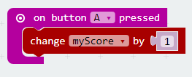
Challenge 2:
Checking to see whether you win. Add an “IF” block to your “button A” block which checks to see how many points the player has and if it is equal to or greater than 10, the micro:bit will tell the player. Remember, the objective of the game is to be the first to gain 10 points. If you get there first, the micro:bit displays the message ‘You Win!’. The code block below shows you how to do it, but you will need to look at some of the other function tabs to see whether you can work out which blocks you need.

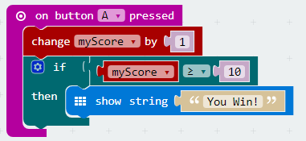

Challenge 3:
Checking to see whether the micro:bit wins. Using the ‘on button B pressed’ code block, you should add a function to your program which counts the micro:bit score each time it guesses the same number that you thought of. Can you look at the code block screenshots here and work out how you might make this function?

