Level 2 – Programming the Guess the Direction game

This task is going to build on the Guess the Number game from the previous lesson. In the last task you created a random number between 0 and 9. Remember that computers count from 0; therefore, creating this random number will give you 10 individual possibilities.

For our ‘Guess the Direction’ game we will use the same principle, but this time create only a random number between 0 and 1 –, i.e. two different possibilities. This is the fundamental underpinning of how binary works – the language that computer processors use.

If we choose a random number, either 0 or 1, we can then use that to represent a choice, which in this case we are going to use to represent left or right. For our game, 0 = left and 1 = right.

The objective of the game is for the micro:bit to choose either left or right randomly and for the user to then try to guess which one was selected.
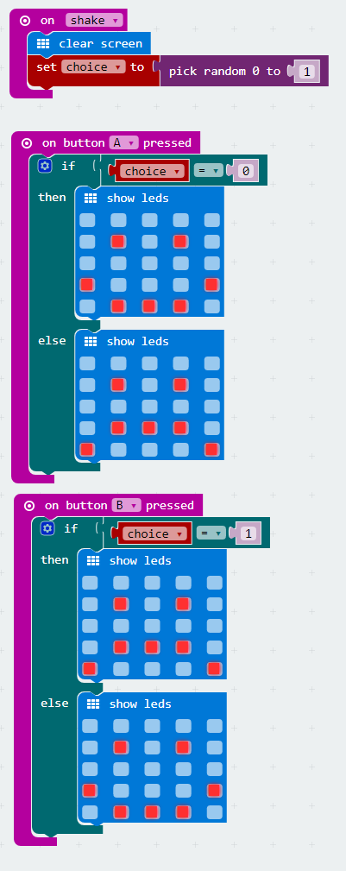
Firstly you will need to clear the screen so that anything which is left on the screen is removed.

Then you need to create a random number – either 0 or 1 – and set the variable ‘choice’ to contain that random number.
To make the game work, now the user needs to guess whether the micro:bit has picked left or right. Remember that 0 = left and 1 = right.

To make this work you need a ‘button A pressed’ event and within that an IF statement which tests to see whether the ‘choice’ variable (remember that was set in the shake event earlier on) is 0 or 1.

Button A is on the left of the micro:bit (if you are looking at it with the cable plugged in at the top); therefore, this needs to test whether our ‘choice’ variable is 0.

If it is, display a smiley face; otherwise display an unhappy face.

The ‘button B pressed’ event is exactly the same, but instead you are looking to see whether the ‘choice’ variable is 1.
Try running your code on your micro:bit and see if you can guess whether it picks left or right.
This isn’t the most interesting game, though, because the user interface is a bit dull. To solve this we need to build up the suspense before the game starts. We can do this by using a FOR…NEXT loop, which makes the micro:bit repeat a task for a set number of times. See next page...
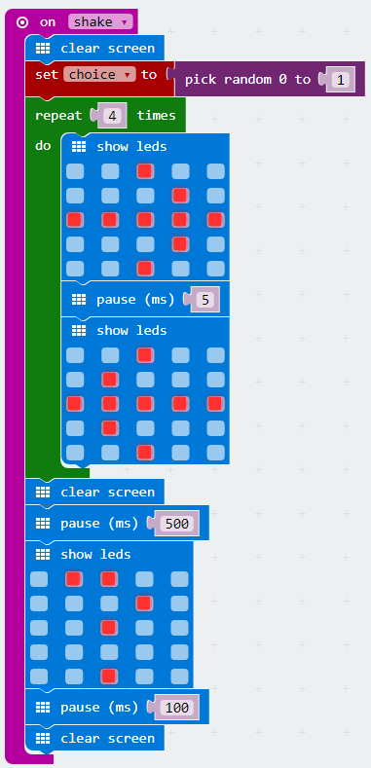
For this task you will need to modify your ‘shake’ event.

Firstly you will need to clear the screen so that anything which is left on the screen is removed.

Then you need to create a random number – either 0 or 1 – and set the variable ‘choice’ to contain that random number.

Then you need to use a repeat loop (which is the micro:bit equivalent to a FOR loop). Set this to repeat 10 times.

Within the loop you need to show a picture of an arrow pointing to the right, then tell the microbit to wait for 5 milliseconds. This will keep the arrow on the screen for a moment in time, then display a left arrow image.

Now, back outside the loop, you need to clear the screen so it is blank, pause for 500 milliseconds (which is half a second), and then show a question mark image. This stays on the screen for 100 milliseconds using another pause and, finally, clear the screen again.

Try running you code on your micro:bit and see if you can guess whether it picks left or right.
Once you have completed the exercise, try out these challenges. Be the programming Ninja!



Challenge 1:
Change the ‘choice’ variable to be a random number between 0 and 2 with 0 = left, 1 = right and 2 = up. Use the ‘button A pressed’ and ‘button B pressed’ events to test to see whether the arrow is pointing up.

Challenge 2:
Use another variable in the button press events to keep score of when the player gets the right direction. Each time they win, increase the score by 1 and display it on the screen.

