Level 1 - Guessing Game Planning Document

Identify what you are going to need in order to make a game which selects a random left or right direction which the user then has to try to guess. The game needs to choose a random number (either 0 or 1) when the micro:bit is shaken. This is then tested when the user presses either the A or B button. If the variable is 0 and the user presses the A button, the micro:bit should display a smiley face. Else it should display a sad face. If the user presses the B button, the opposite should happen. Think about the problem and break it down into its component parts

Block | Code block | Reason/explanation
Input | 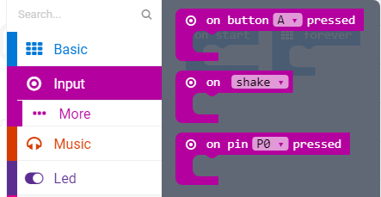
Creating a variable to store something | 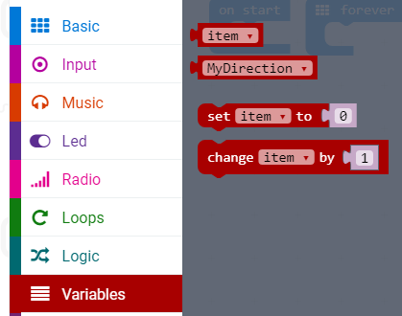
Basic display | 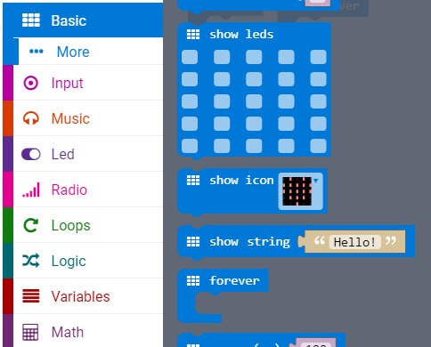
Logic functions | 