Level 1 - Creating Your First Program

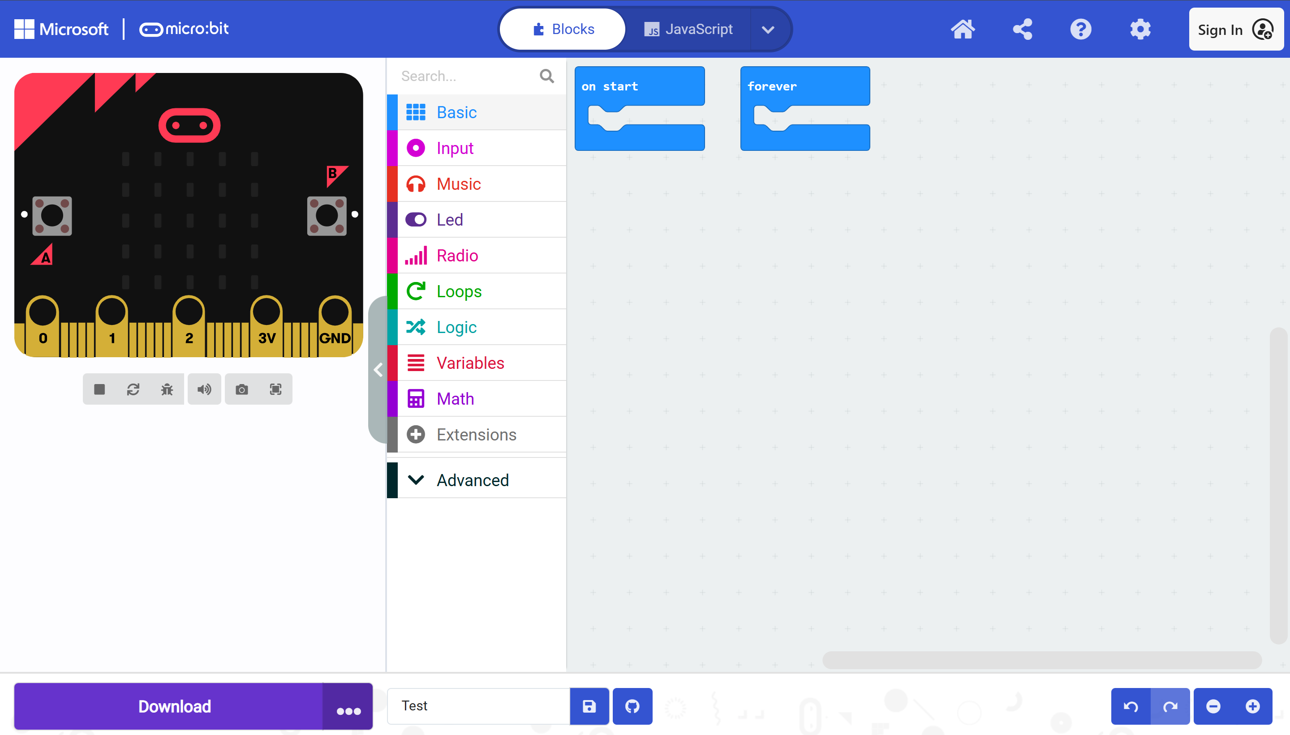

Go to https://makecode.microbit.org/ this will be the website you will use to code the micro:bit in this topic.

This will display the Blocks Editor, which you will use for programming. On the left-hand side of the screen is a ‘preview’ micro:bit. As you create your program, you can click on the buttons, etc. in this preview to see your program running and try it. In the middle of the screen are the different code tabs for the main functions of the micro:bit. On the right of the screen is where you will drag code blocks from the function tabs and put them together in order to create your application. This is sort of a programming ‘paste board’.

So, how do you create a program on the micro:bit? It is actually very simple to do, especially if you have used the Scratch programming system previously – it works in the same way. To create your first basic application:

Step 1:
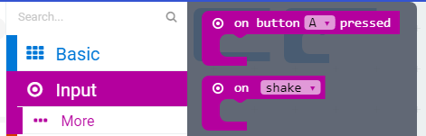
Click on the ‘Input’ function tab in the middle of the screen and double-click on the ‘on button A pressed’ block. This will add it to the programming paste board.

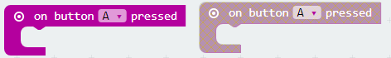
Repeat this step so that you have two of these blocks on the paste board.

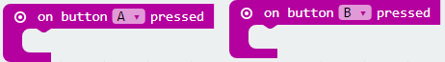
Step 2:
Using one of the code blocks, click the drop-down menu next to the letter A and change it to B.

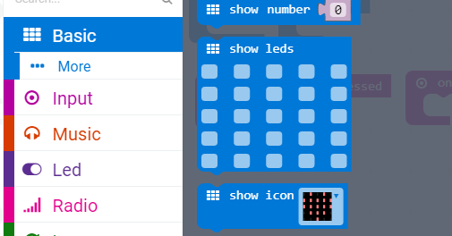
Step 3:
Click on the ‘Basic’ function tab and double-click on the ‘show leds’ code block to add it to your program. Again, repeat this so that you have two blocks.
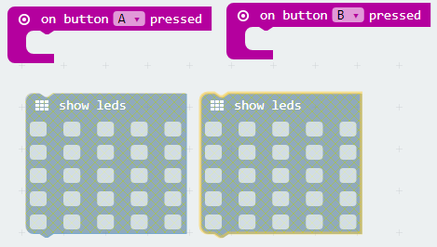
You can see that they are greyed out because they are ‘floating’ – i.e. they are outside a code block. If you look at the ‘on button A pressed’ blocks you can see that they wrap around. These are used to ‘wrap around’ code by attaching blocks to each other. This means that when button A is pressed, it will do everything which is wrapped inside its block.

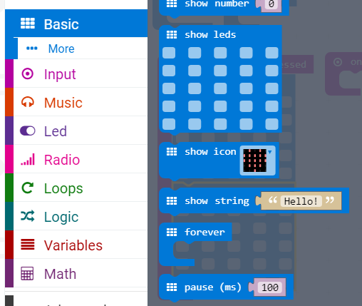
Step 4:
Click on the ‘Basic’ function tab and double-click on the ‘pause’ block to add it to your program.

Step 5:
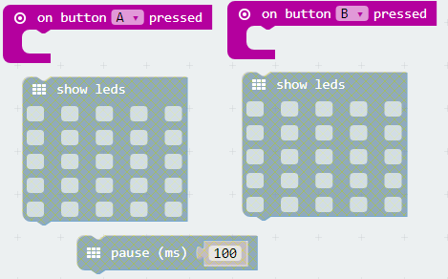
On your paste board you should now have something similar to the image below:

The greyed-out blocks are not attached to anything. To attach them, simply drag them into the space in the middle of the ‘on button A pressed’ block. You can see there is a small bump/dent on each block to show where they line up. Drag the greyed-out blocks into the ‘on button A pressed’ block. You should get something similar to the image below:
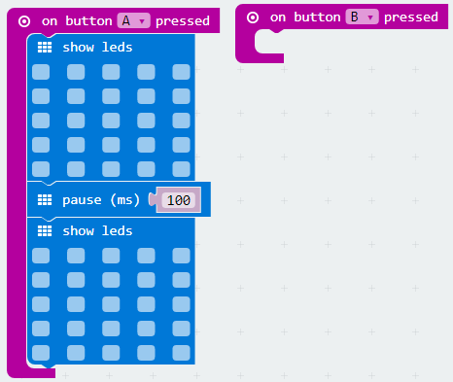

The blocks are now attached, and, therefore, no longer greyed out. If your blocks are in the wrong order, you can simply either drag them out and rearrange them, or drag them around within blocks to change the order.
When your program runs, the micro:bit will perform the blocks in order from top to bottom. The above program will perform an LED function, then wait 0.1 seconds, then perform a second LED function when button A is pressed. Since none of the LEDs is told to switch on in either function, though, it will be a pretty dull program!

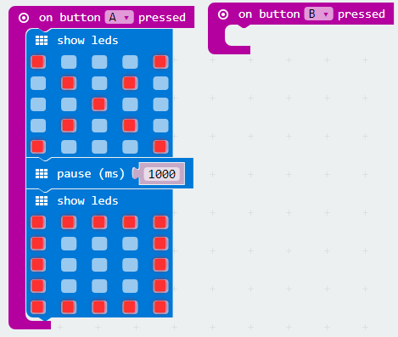
Step 6:
Click on the squares in the ‘show leds’ block to switch on the different LED lights on the front of the micro:bit. Then change the number in the ‘pause’ block to ‘1000’ by clicking on it and typing in a new number. The pause is measured in milliseconds; therefore, 1,000 equals one second. The above program will now display a cross, then wait one second, then display a square. The program works step by step from top to bottom within each block.

Step 7:
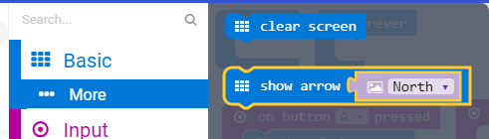

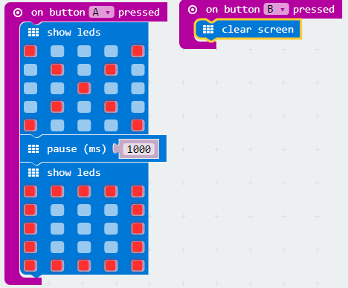
Click on the ‘Basic’ function tab and select ‘More’ then double-click on ‘clear screen’ to add that block to your program.

Drag the ‘clear screen’ block into the ‘on button B pressed’ block to attach it to that button.

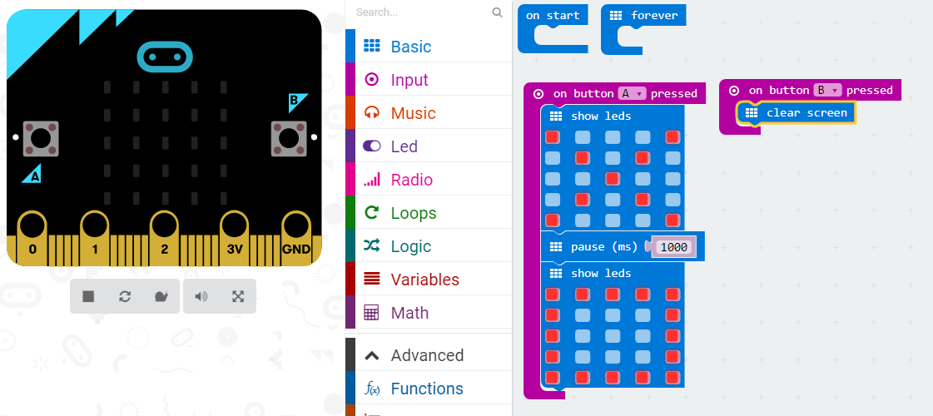
Step 8:
Using the ‘preview’ micro:bit on the left-hand side of the screen, click the A and B buttons to try out your program. These are the small round buttons with either an A below it (on the left) or a B above it (on the right). This will show your program working. You have just made your first micro:bit program.

