Social engineering
Activity 1: Phishing

A phishing attack is an attack in which the victim receives an email disguised to look as if it has come from a reputable source, in order to trick them into giving up valuable data.

The email usually provides a link to another website where the information can be inputted.

What three pieces of advice would you give to someone to stop them from becoming the victim of a phishing attack?

1.
2.
3.

Activity 2: Blagging

Underline and number the parts of the email that make it suspicious; complete the table below to describe why it’s suspicious (an example has been provided).

Go to Insert and then Shapes and draw a line to underline suspicious parts. To add a number go to Insert and then Text Box, type the number into the text box.

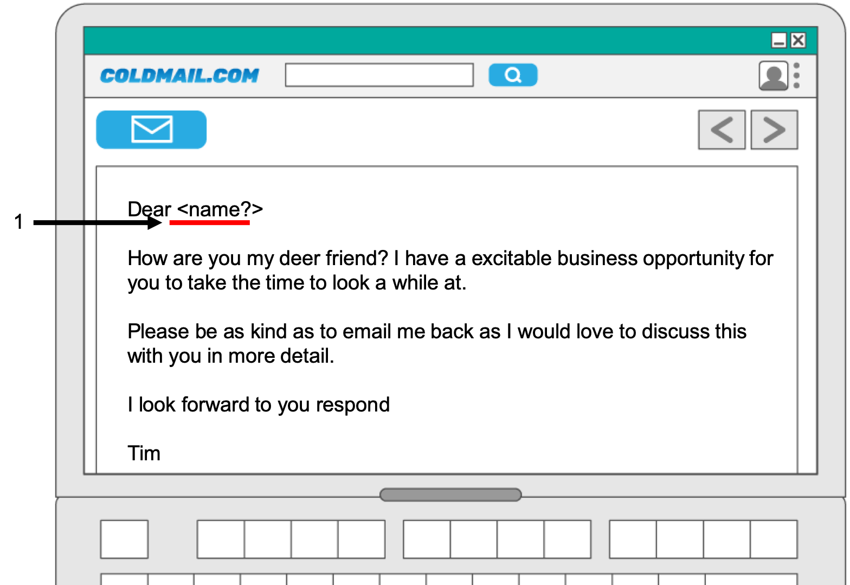

Number | Reason
1.
2.
3.

Activity 3: Video

Consider the following questions while watching the video your teacher will display on the projector and answer them after the video has finished.

What is the difference between phishing and blagging?
Think about what happens on this video. Was it phishing or blagging?
What aspects of the email made it suspicious?

Activity 4: Protecting your customers

Put yourself in the shoes of the cybersecurity team of a national bank. Your job is to try to prevent your customers becoming victims of social engineering.

4.1. Complete the information poster below.

 | Shouldering  Keep your pins and passwords safe from shouldering.  What is shouldering?  What can I do to stop myself becoming a victim?

4.2 Blagging/phishing email

Write a short blagging email that tries to convince the recipient that they need to send you some money. Add in some obvious characteristics that are common in blagging emails.

Give advice to the customers on how to spot a blagging or phishing email.

Scam email warning!

Three ways to spot a scam email:

1.
2.
3.

Explorer activity – Complete this to earn a positive point

Using the links to the UK National Cyber Security website to help you, answer the following questions:

Question | Your answer
Describe what is meant by the term ‘spear phishing’?

(https://www.ncsc.gov.uk/guidance/phishing)
Read the advice about spotting phishing emails. What tips did you find that you haven’t listed in the advice you gave in task 4.2?

(https://www.ncsc.gov.uk/guidance/suspicious-email-actions)
What is two-factor authentication?

(https://www.ncsc.gov.uk/guidance/setting-two-factor-authentication-2fa)

Resources are updated regularly — the latest version is available at: ncce.io/tcc.

This resource is licensed under the Open Government Licence, version 3. For more information on this licence, see ncce.io/ogl.

