Level 3 - Comprehension

Background information
How are binary digits stored and processed in digital devices?

Electronic components
Examples: processors (CPU, GPU), main memory (RAM), some storage devices (flash drives, SD cards, solid state disks).  In electronic components, 0s and 1s are represented by the flow of electricity, controlled by interconnected switches. | 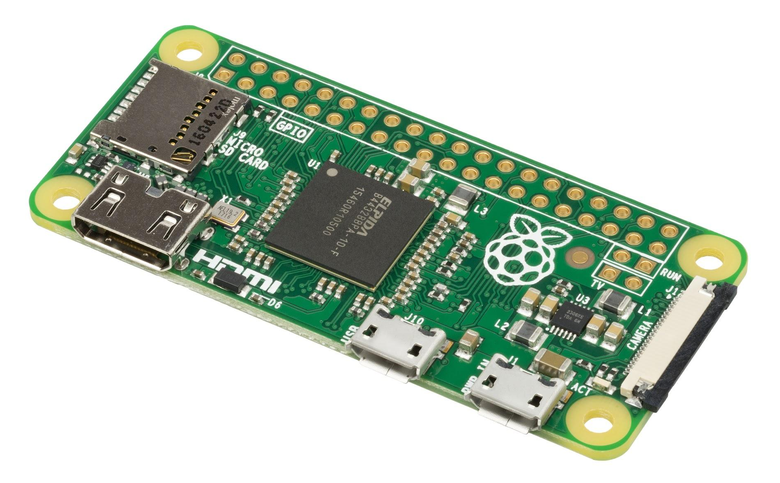

The past
Perforated paper  Perforated paper (in long strips or cards) was used for storing programs and data.  0s and 1s were represented by the presence or lack of holes in paper. | 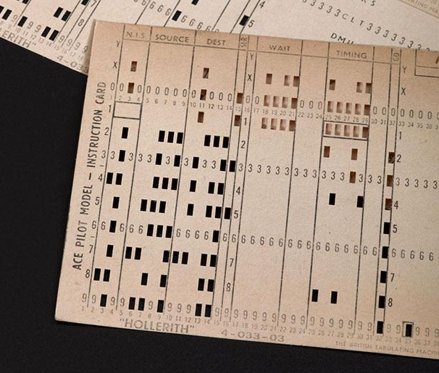
Magnetic core memory  The cores were metal rings, connected with wires. Each ring (core) stored one bit. Electricity was used for writing and reading the information in the cores.  0s and 1s were represented by the way in which each core was magnetised. | 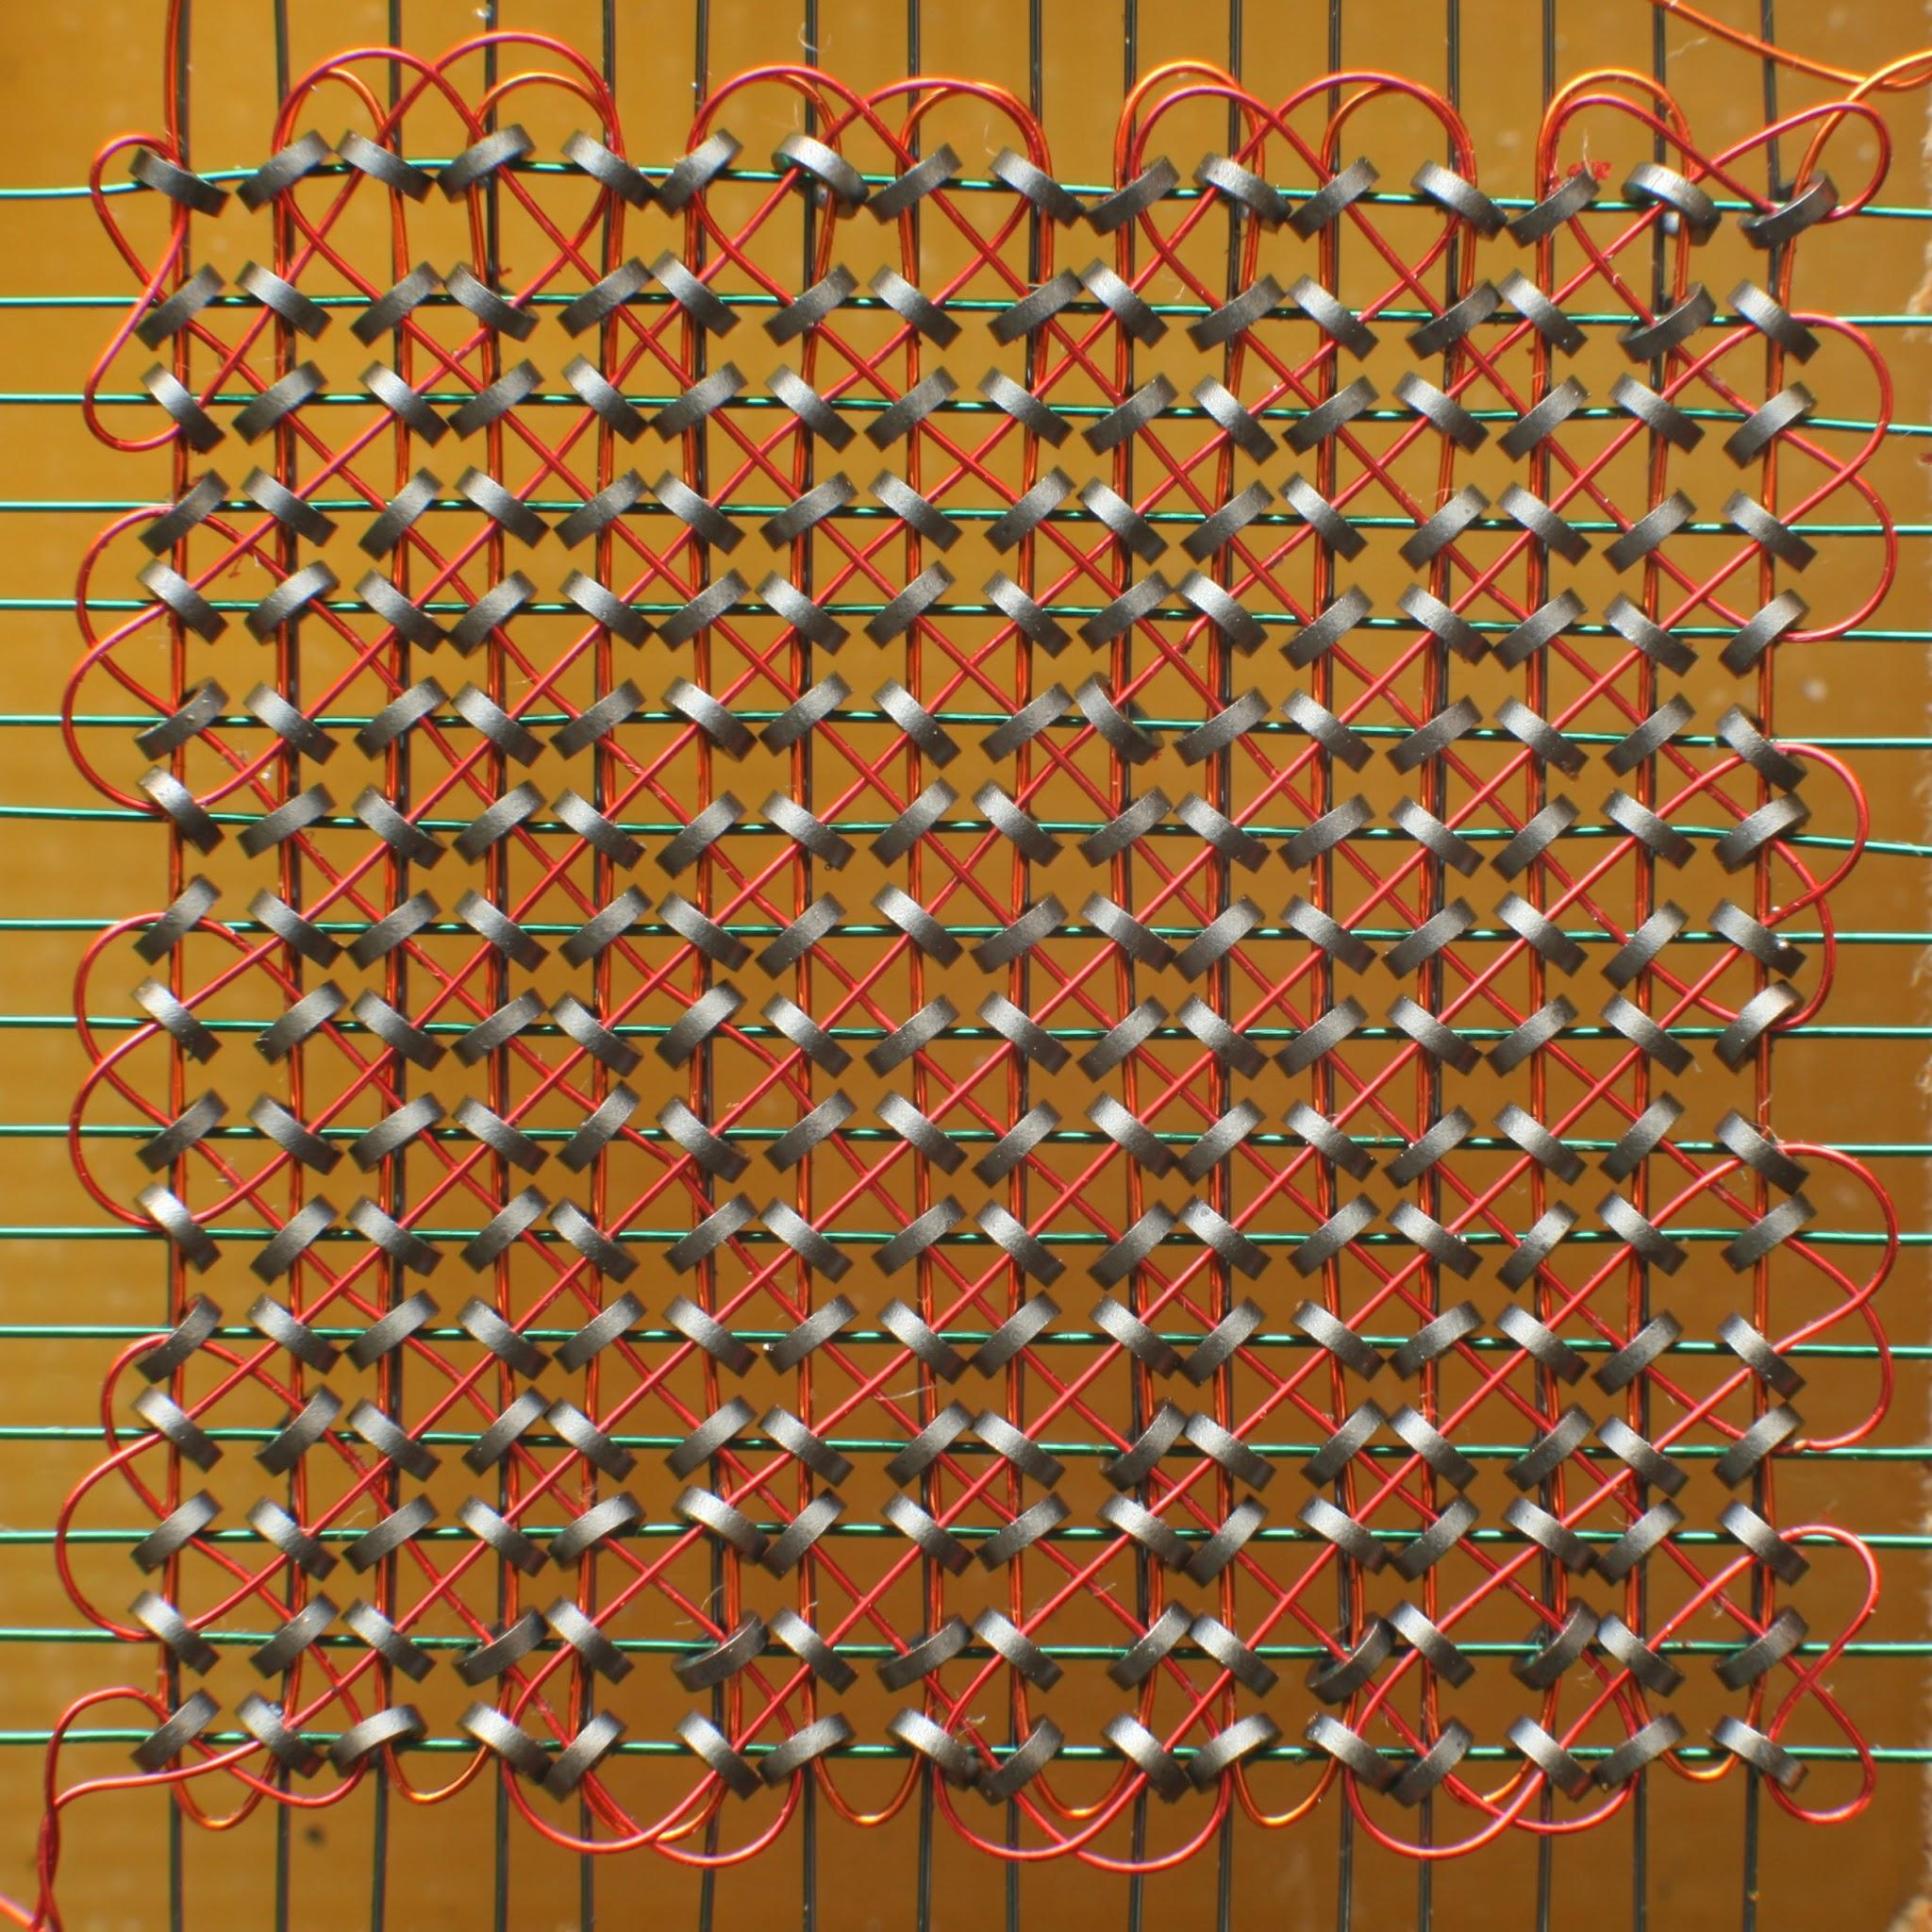

Hard disks | Hard disk: 1TB = 8 trillion binary digits
The material on the surface of hard disks is magnetic. 0s and 1s are represented as changes in the magnetic orientation (N-S or S-N) of individual regions on the surface.  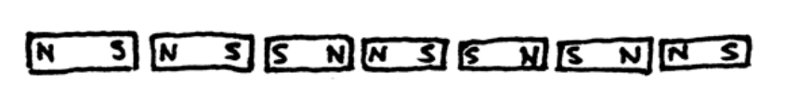 | 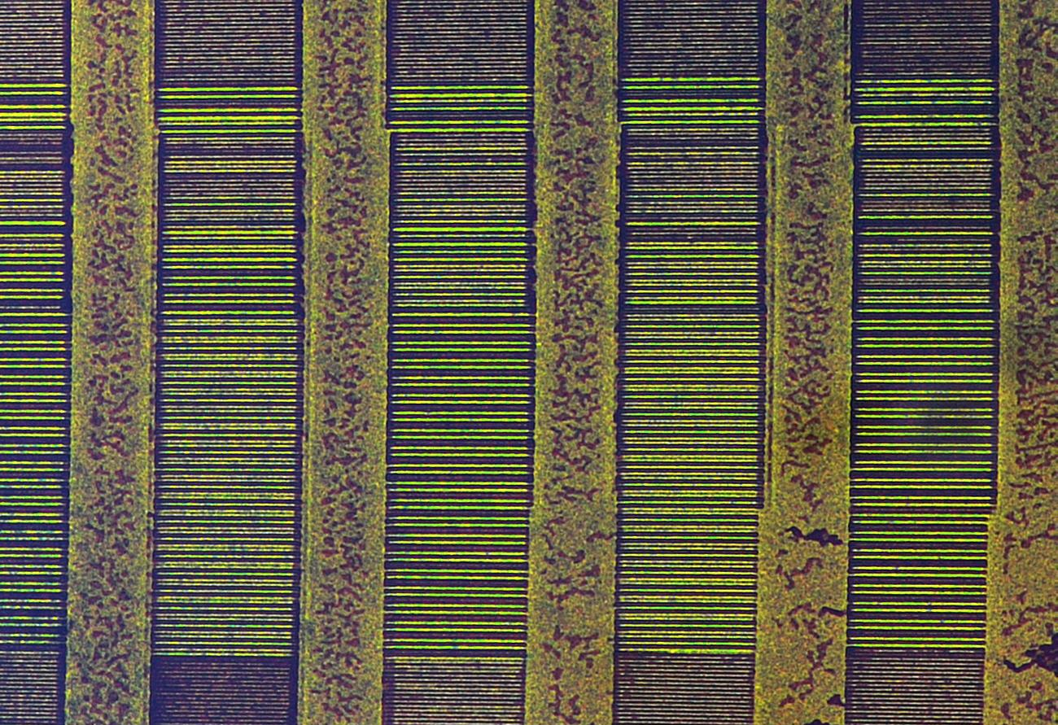
Optical disks | CD: 700MB = 5.6 billion binary digits
Examples: CDs, DVDs, and Blu-ray Discs.  The surface of optical disks is reflective. 0s and 1s are represented by pits (microscopic holes) or lands (regions without holes).  Light is used to read the binary digits off the surface of the disk.  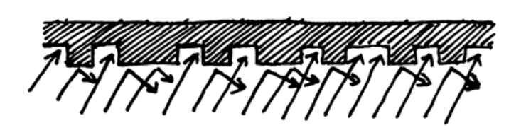 | 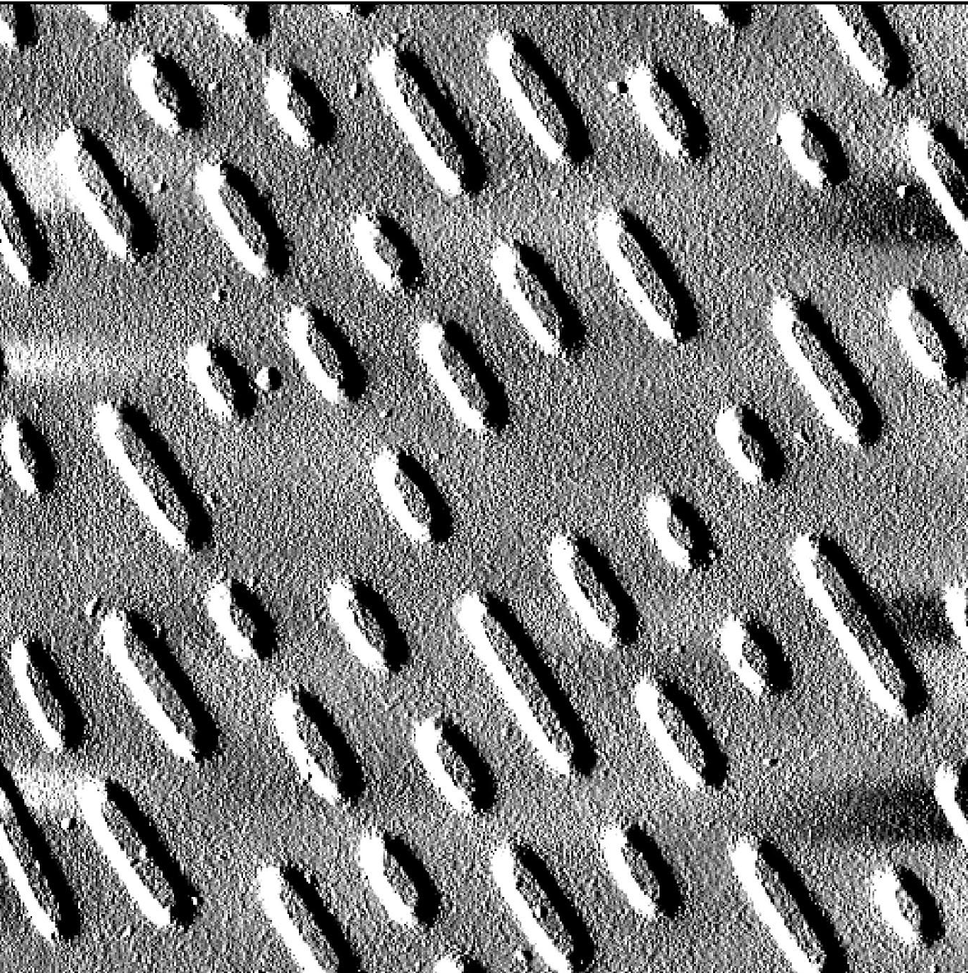

Scroll Down

How are binary digits transmitted between digital devices?
Wired connections  Binary digits are transferred through wires using electricity.  Binary digits are transferred through fibre-optic cables using light. | 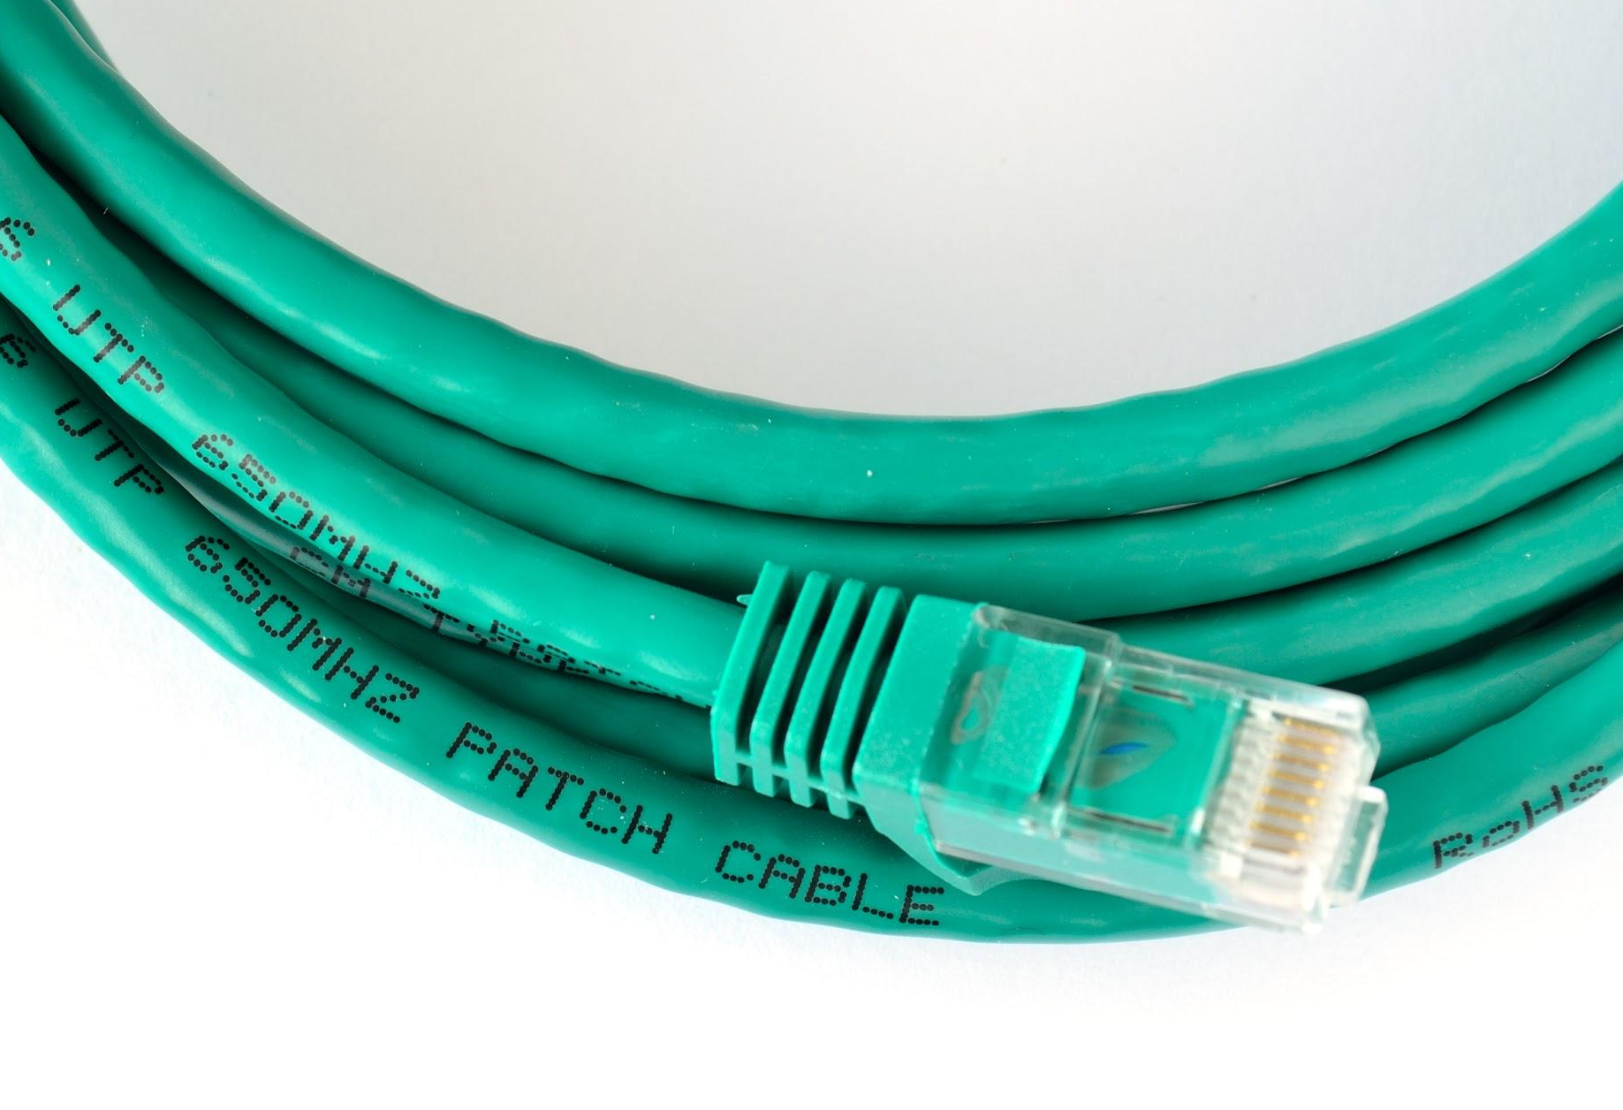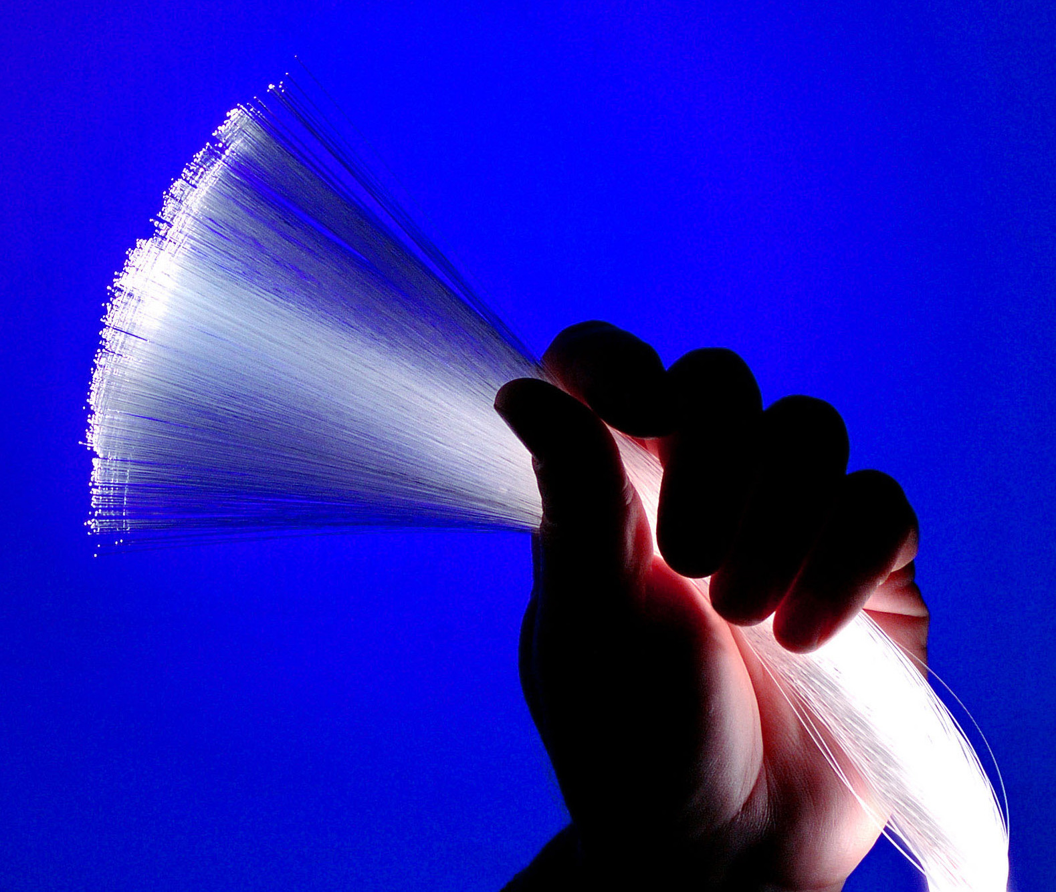
Wireless connections  In all wireless communications, binary digits are transferred using electromagnetic waves, transmitted and received by antennae. | 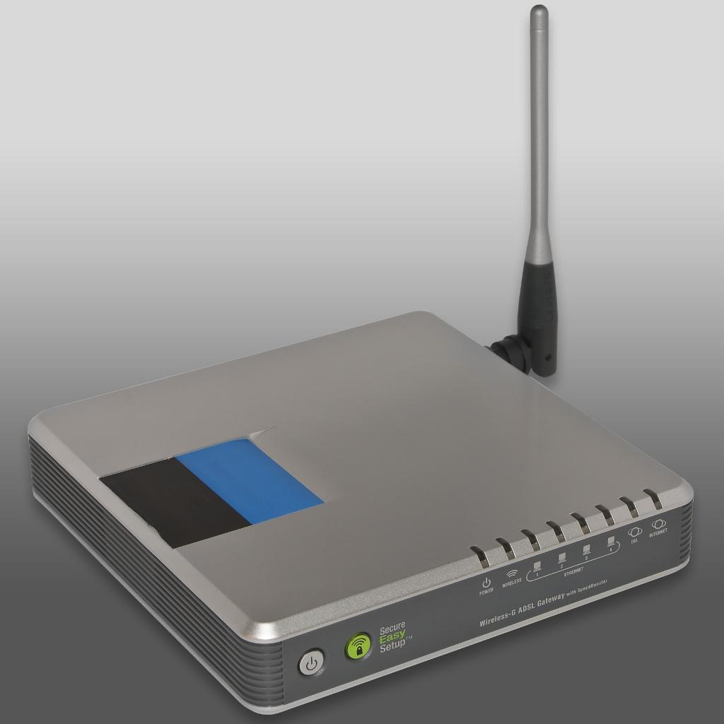

Study the background information provided on these pages and answer the questions below.
Highlight the correct answers.

Questions Where are the 0s and 1s?
- What do electronic circuits use to represent and process binary digits?
  - Sound
  - Light
  - Electricity
  - Magnetism
- What do hard disks use to represent and process binary digits?
  - Sound
  - Light
  - Electricity
  - Magnetism

- What do optical disks (such as CDs, DVDs, and Blu-ray Discs) use to represent binary digits?
  - Sound
  - Light
  - Electricity
  - Magnetism
- Which of the following are used to transmit information between digital devices? (Select all of the answers that you believe to be correct. There may be more than one.)
For each of the options that you select, provide a specific example:
- Sound Example: .................................................
- Light Example: .................................................
- Electricity Example: .................................................
- Magnetism Example: .................................................
- Water Example: .................................................
- Electromagnetic waves Example: .................................................

Questions Prefixes
Project Gutenberg is a digital library. Its website allows users to download books that are in the public domain (i.e. they are not restricted by intellectual property rights).
You find and download a classic work of English literature. It is 720KB (kilobytes) in size.
- How many bytes is 720KB (kilobytes)?
  - 720 bytes
  - 90 thousand bytes
  - 720 thousand bytes
  - 5,760 thousand bytes
  - 720 million bytes
- How many bits is 720KB (kilobytes)?
  - 720 bits
  - 90 thousand bits
  - 720 thousand bits
  - 5,760 thousand bits
  - 720 million bits
BBC Radio allows users to download and listen to podcasts (audio files containing anything from news to theatrical plays).
You download your favourite podcast, which is exactly 24,763,158 bytes in size.
- Which unit would you find most appropriate to describe this size of 24,763,158 bytes?
  - Kilobytes
  - Megabytes
  - Gigabytes
  - Terabytes

This resource is licensed under the Open Government Licence, version 3. For more information on this licence, see ncce.io/ogl.

