Level 3 – Pixel art picture

Can you put together a set of instructions to create one of the following pictures in a spreadsheet? You should use the kind of instructions you followed in Level 2.

If you prefer, you can create your own small picture first and then put together the instructions for that.

- Can you work out how to resize a column? If you are not sure, search the internet.
- Top tip: If you select several columns at the same time you can resize them all together
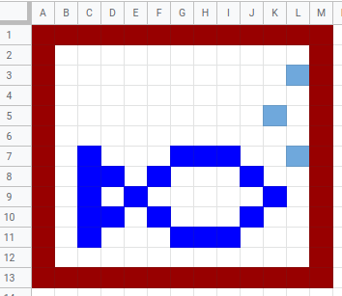
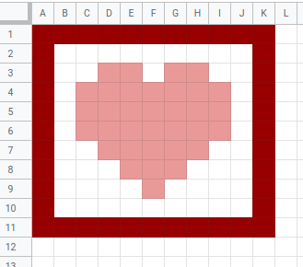
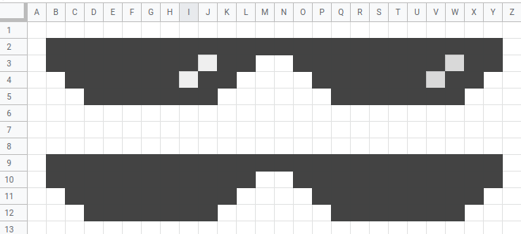
Write your instructions here:

Resources are updated regularly — the latest version is available at: ncce.io/tcc.

This resource is licensed under the Open Government Licence, version 3. For more information on this licence, see ncce.io/ogl.

