Level 2 – Pixel art
In this activity, you will draw some flags by colouring in cells in a spreadsheet. Can you guess which country each flag belongs to?

Firstly you should open the Microsoft Excel program on your computer, you can find it in the start menu, you should then open a new blank file.

- Top tip: If you make a mistake, you can use the Undo command to undo the last thing you did.

Flag 1
Apply a black fill colour to the following cells:
- A1:F5

Step-by-step guide
Prefer to do it step by step? Here are the cells you need to colour:

A1:A5 | B1:B5 | C1:C5 | D1:D5 | E1:E5 | F1:F5

Hint: A1:A5 means cells 1 to 5 in column A

Apply a red fill colour to the following cells:
- A6:F10

Step-by-step guide
Here are the cells you need to colour:

A6:A10 | B6:B10 | C6:C10 | D6:D10 | E6:E10 | F6:F10

Apply a yellow fill colour to the following cells:
- A11:F15

Step-by-step guide
Here are the cells you need to colour:

A11:A15 | B11:B15 | C11:C15 | D11:D15 | E11:E15 | F11:F15

Flag 2
Apply a blue fill colour to the following cells:
- A21:B35

Step-by-step guide
Prefer to do it step by step? Here are the cells you need to colour:

A21:A35 | B21:B35

Hint: A1:A5 means cells 1 to 5 in column A

Leave the following cells white:
- C21:D35

Apply a red fill colour to the following cells:
- E21:F35

Finally, make the flag stand out by putting a border around it.
- Select all of the cells A21:F35 and apply a border around the outside only.
- Can you work out how to change the thickness of the border?

Flag 3
Apply a blue fill colour to the following cells:
- A41:B46
- A50:B55
- D41:F46
- D50:F55

Apply a yellow fill colour to the following cells:
- C41:C55
- A47:F49

Explorer Task

You have now created three flags following the instructions above, now try to create some of the following flags yourself in the spreadsheet you have been using.

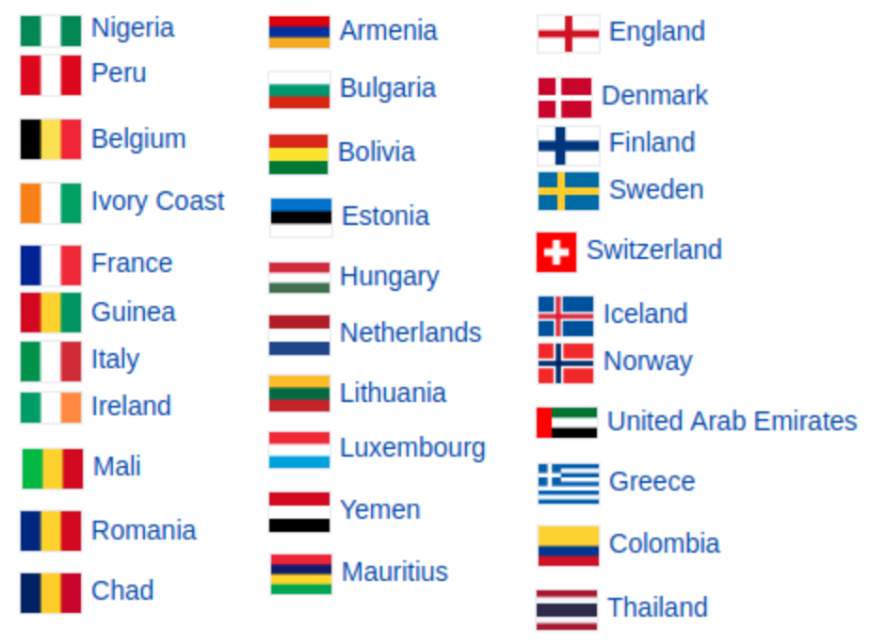

Resources are updated regularly — the latest version is available at: ncce.io/tcc.

This resource is licensed under the Open Government Licence, version 3. For more information on this licence, see ncce.io/ogl.

