L1 - Homework Name: Date due:

Colour in your chosen flag here:
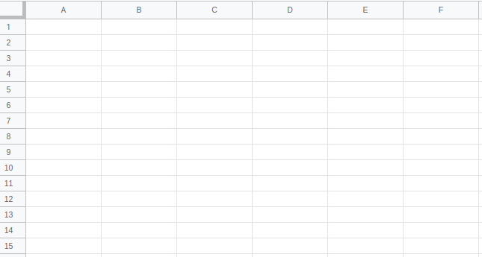

Now write out a set of instructions in the box below describing how to make this flag in a spreadsheet:

Remember:
- A5:A10 means the cells in column A from row 5 up to row 10
- C1:D15 means the cells in column C and in column D from row 1 up to row 15

