Level 1: Mapping the data
In pairs, study the map and answer the questions below:

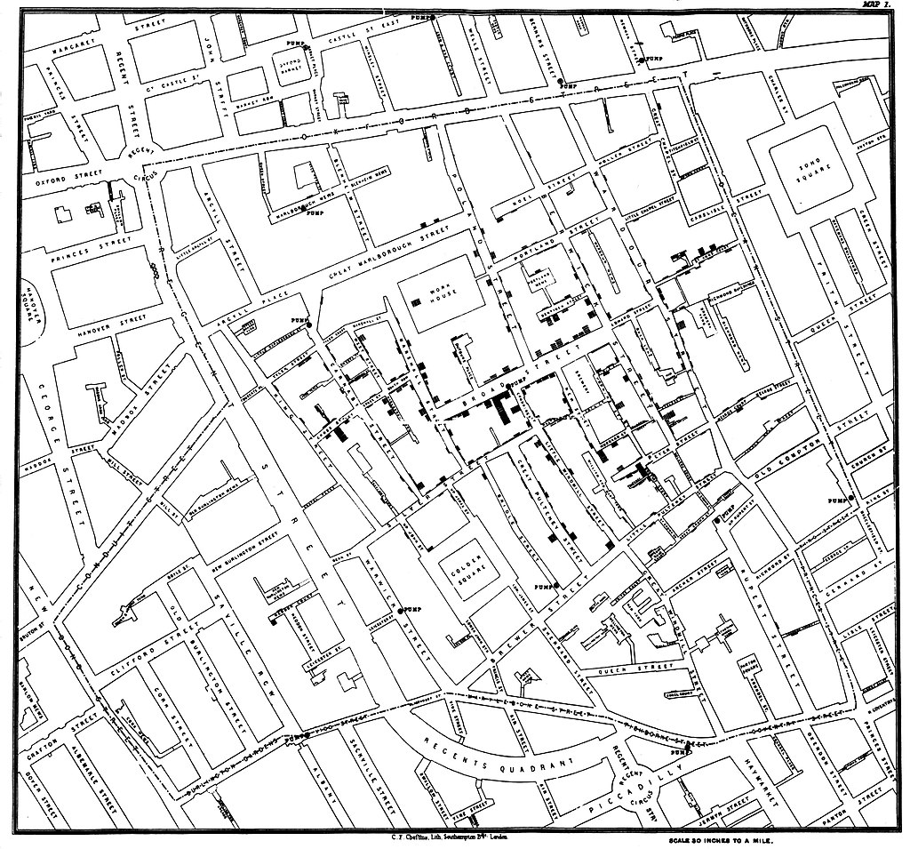

- What conclusions (if any) can you draw from looking at the map? Justify your answer.
Here is the area of the map around Broad Street.
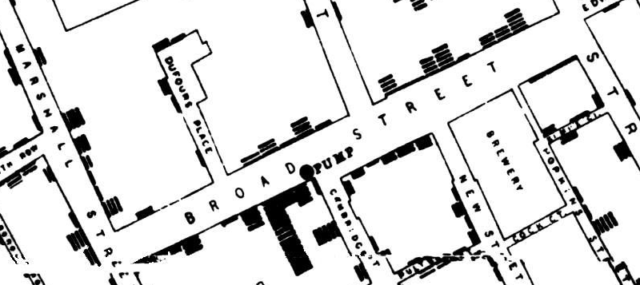
- What is highlighted in this area that isn’t anywhere else on the map?
- What is the link between the highlighted item on Broad Street and the dotted items?

How does the map help to disprove the theory that cholera was caused by pollution in the air?

- Does the map alone disprove the theory? Justify your answer.

Resources are updated regularly — the latest version is available at: ncce.io/tcc.

This resource is licensed under the Open Government Licence, version 3. For more information on this licence, see ncce.io/ogl.

