Level 1 - Gears again
Task 1 .
Open a browser window and visit ncce.io/tt-gears-1. You will see a geared mechanism that performs some sort of computation.
- You can set the direction of the input gear at the top by clicking on the gear (it can point either left or right).
- You can release a ball and activate the mechanism by clicking on the balls.
- After the ball goes through the mechanism, you can observe the direction of the output gear (it can point either left or right).
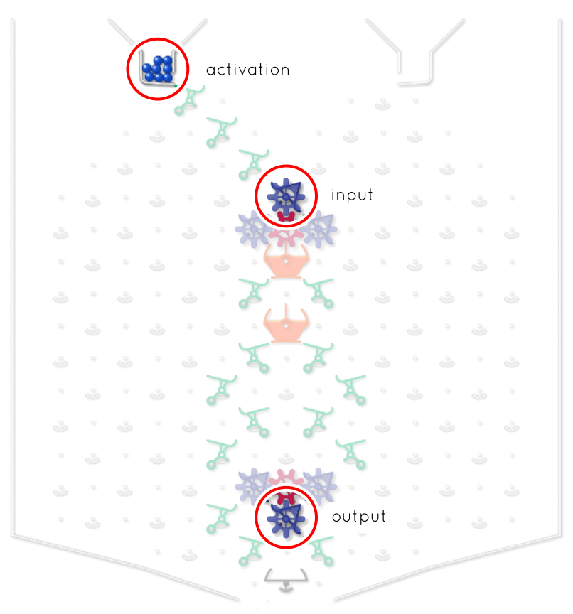

For each row in the table below:
- Set the input gear as indicated in the table.
- Activate the mechanism.
- Observe and write down the output, i.e. the direction of the output gear.
Input gear | Output gear
Gear pointing left   | Gear pointing .
Gear pointing right   | Gear pointing .
Complete the sentence below to describe the behaviour of the mechanism.
The output gear points to the right when:

Task 2 .
Open a browser window and visit ncce.io/tt-gears-2. You will see a geared mechanism that performs some sort of computation.
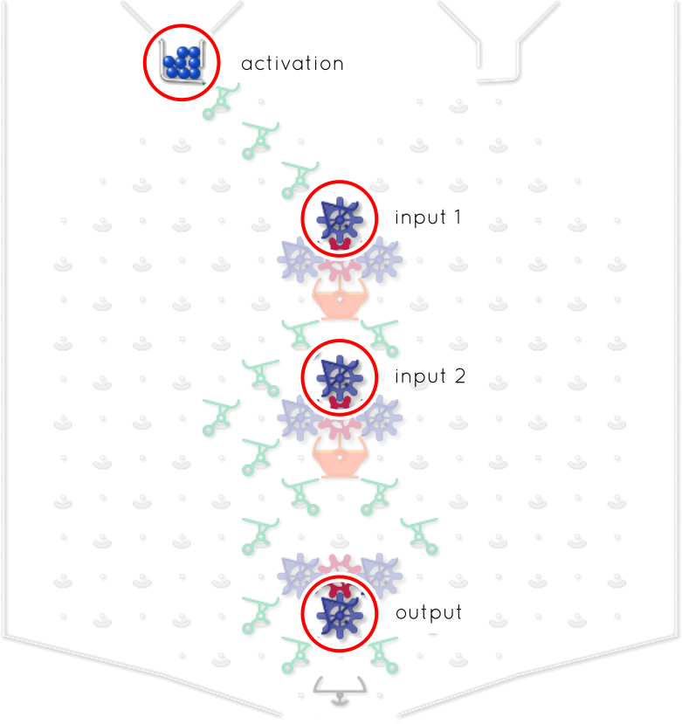

For each row in the table below:
- Set each of the two input gears as indicated in the table.
- Activate the mechanism.
- Observe and write down the output, i.e. the direction of the output gear.
Input gear 1 | Input gear 2 | Output gear
Gear pointing left | Gear pointing left | Gear pointing .
Gear pointing left | Gear pointing right | Gear pointing .
Gear pointing right | Gear pointing left | Gear pointing .
Gear pointing right | Gear pointing right | Gear pointing .
Complete the sentence below to describe the behaviour of the mechanism.
The output gear points to the right when:

Explorer task .
Open a browser window and visit ncce.io/tt-gears-3. You will see a geared mechanism that performs some sort of computation.
Initially, all the gears in the mechanism point to the left.
Release a ball to activate the mechanism and write down the new position of the gears. Repeat the process until you are able to answer the following question: what sort of computation is the machine performing?
 | Gear 4  (bottom) | Gear 3 | Gear 2 | Gear 1  (top)
 | Gear pointing  . | Gear pointing  . | Gear pointing  . | Gear pointing  .
 | Gear pointing  . | Gear pointing  . | Gear pointing  . | Gear pointing  .
 | Gear pointing  . | Gear pointing  . | Gear pointing  . | Gear pointing  .
 | Gear pointing  . | Gear pointing  . | Gear pointing  . | Gear pointing  .
 | Gear pointing  . | Gear pointing  . | Gear pointing  . | Gear pointing  .
 | Gear pointing  . | Gear pointing  . | Gear pointing  . | Gear pointing  .
 | Gear pointing  . | Gear pointing  . | Gear pointing  . | Gear pointing  .
 | Gear pointing  . | Gear pointing  . | Gear pointing  . | Gear pointing  .

This resource is licensed under the Open Government Licence, version 3. For more information on this licence, see ncce.io/ogl.

