ISBN
Every book published after 2007 is assigned a unique 13-digit code called ISBN (International Standard Book Number). Here are a few examples:
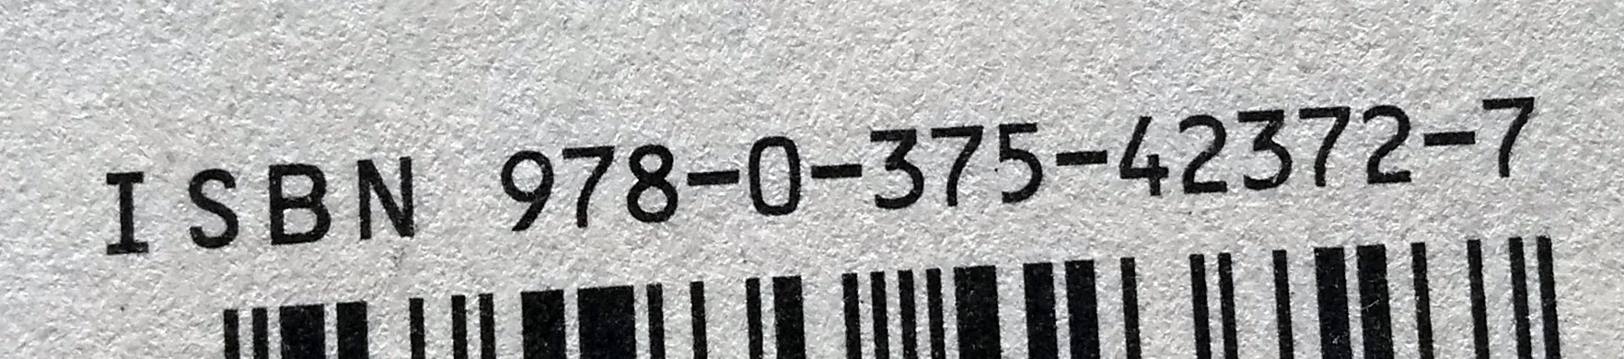
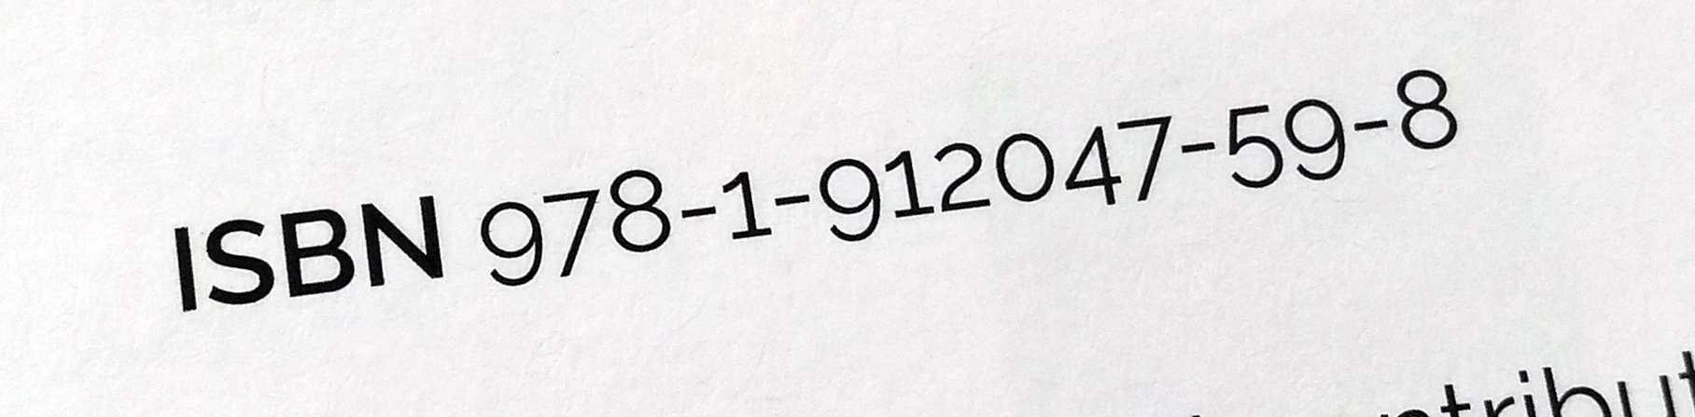
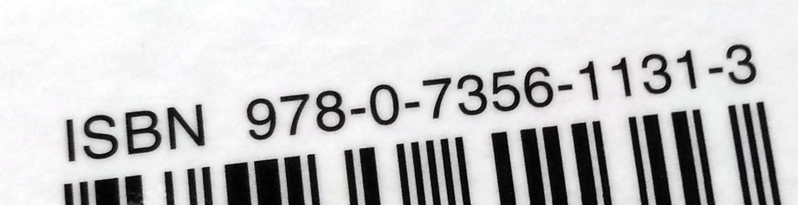
In order for an ISBN to be valid, the weighted sum of the 13 digits (where each digit is multiplied by a weight alternating between 1 and 3) must be a multiple of 10.
Example:
The Information: A History, A Theory, A Flood
by James Gleick (2011)
ISBN: 9780375423727

digits | 9 |  | 7 |  | 8 |  | 0 |  | 3 |  | 7 |  | 5 |  | 4 |  | 2 |  | 3 |  | 7 |  | 2 |  | 7
 | ⨉ |  | ⨉ |  | ⨉ |  | ⨉ |  | ⨉ |  | ⨉ |  | ⨉ |  | ⨉ |  | ⨉ |  | ⨉ |  | ⨉ |  | ⨉ |  | ⨉
weights | 1 |  | 3 |  | 1 |  | 3 |  | 1 |  | 3 |  | 1 |  | 3 |  | 1 |  | 3 |  | 1 |  | 3 |  | 1
 | 9 | + | 21 | + | 8 | + | 0 | + | 3 | + | 21 | + | 5 | + | 12 | + | 2 | + | 9 | + | 7 | + | 6 | + | 7 | = | 110
Example:
Adventures in Raspberry Pi
by Carrie Anne Philbin (2013)
ISBN: 9781118751251

digits | 9 |  | 7 |  | 8 |  | 1 |  | 1 |  | 1 |  | 8 |  | 7 |  | 5 |  | 1 |  | 2 |  | 5 |  | 1
 | ⨉ |  | ⨉ |  | ⨉ |  | ⨉ |  | ⨉ |  | ⨉ |  | ⨉ |  | ⨉ |  | ⨉ |  | ⨉ |  | ⨉ |  | ⨉ |  | ⨉
weights | 1 |  | 3 |  | 1 |  | 3 |  | 1 |  | 3 |  | 1 |  | 3 |  | 1 |  | 3 |  | 1 |  | 3 |  | 1
 | 9 | + | 21 | + | 8 | + | 3 | + | 1 | + | 3 | + | 8 | + | 21 | + | 5 | + | 3 | + | 2 | + | 15 | + | 1 | = | 100

If you get stuck with your Python try looking at the last page for some clues.

Task 1. Compute the weighted sum
Create a Python program that prompts the user to enter an ISBN (as a single piece of text) and then computes and displays the weighted sum of its digits.
Example
Note: Use this example to check your program. This is the output your program should produce for the given input.
The program displays a prompt and waits for keyboard input | Enter an ISBN:
The user types a reply | 9780375423727
The program displays the weighted sum | Weighted sum: 110

Note: For the purposes of this task, you can assume that the user input will be 13 characters long and will only contain numerical digits. If other characters are included, your program will terminate with a ValueError but you don’t need to worry about that.

Checklist: Tick (✔) the corresponding box if your program:
Prompts the user for an ISBN and reads it as a piece of text (a string).
Computes and displays the weighted sum of its digits.

Task 2 . Check validity
Extend your program to check the weighted sum and determine if the ISBN is valid.
Example
Note: Use this example to check your program. This is the output your program should produce for the given input.
The program displays a prompt and waits for keyboard input | Enter an ISBN:
The user types a reply | 9780375423727
The program displays the weighted sum and whether or not the ISBN is valid | Weighted sum: 110  This is a valid ISBN
Example
Note: Use this example to check your program. This is the output your program should produce for the given input.
The program displays a prompt and waits for keyboard input | Enter an ISBN:
The user types a reply | 9780375423728
The program displays the weighted sum and whether or not the ISBN is valid | Weighted sum: 111  This is not a valid ISBN

Checklist: Tick (✔) the corresponding box if your program:
Checks if the weighted sum is a multiple of 10 and displays a message that informs the user whether or not the ISBN is valid.

Take a screenshot of your code that does both tasks and upload to Teams for Level 3.

Clues . Look here if you need help
What are the variables I will need?
Think about the quantities you will need to refer to in your program, the values that your program will need to keep track of.
You will probably need:
- The isbn entered by the user (as a piece of text)
- Each individual character in the ISBN
- Each individual digit in the ISBN
- The weight associated with each digit
- The weighted sum
How do I iterate over the digits in the ISBN?
Read the isbn as a piece of text, i.e. don’t convert it to a number directly, so that it is easier to iterate over individual characters.
Use a for-loop to iterate over each character in the ISBN. Use the int function to convert each character into a digit. The pseudocode below illustrates this idea:
for character in isbn:
digit = int(character)
process the digit

How do I compute the weighted sum of the ISBN digits?
A sum can be accumulated by adding each term iteratively to the sum, using an assignment like this:
sum = sum + term

In this case, the term will be the product of a digit by its associated weight. Don’t forget to initialise the sum.
How do I alternate the weight between 1 and 3?
You can check if it is equal to 3 and then set it to one and vice versa.
There’s also another way: remember that the sum of two consecutive weights is always 4. So if you know the current value of the weight, it’s straightforward to compute the next value as well.
How do I check if the weighted sum is a multiple of 10?
If you divide a number by 10 and there is no remainder (i.e. the remainder equals zero), then this number is a multiple of 10.
Use the % operator to compute the remainder of any integer division. For example, this expression computes the remainder of dividing sum by 10:
sum % 10

This resource is licensed under the Open Government Licence, version 3. For more information on this licence, see ncce.io/ogl.

